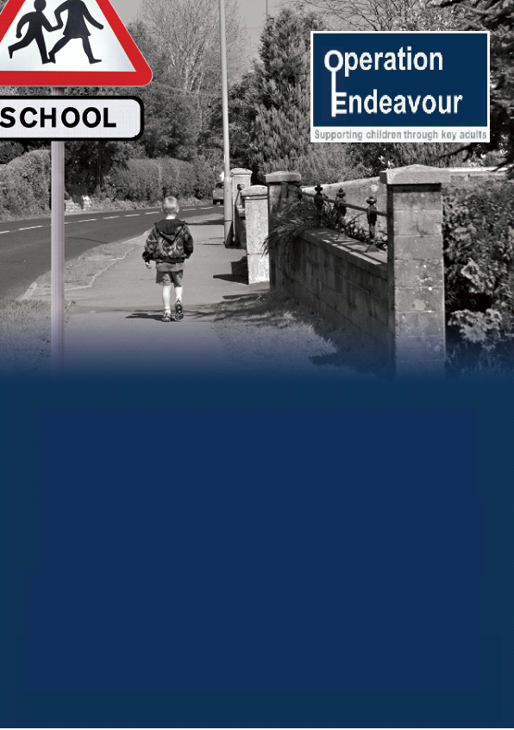

The local authority contact for **Operation Endeavour** is Leigh Mcdougle, Education Officer, MASH, 0191 2772132 [Leigh.Mcdougle@newcastle.gov.uk](mailto:Leigh.Mcdougle@newcastle.gov.uk)

Northumbria Police contact for **Operation Endeavour** is Sergeant Sharron Brennan, Missing from Home Co-ordinator, Ext 74269 [Sharron.Brennan.8217@northumbria.pnn.police.uk](mailto:Sharron.Brennan.8217@northumbria.pnn.police.uk)

**Operation Endeavour** is a safeguarding arrangement between Newcastle Children’s Social Care Service, Northumbria Police and schools and colleges in Newcastle to safeguard children and young people at risk of harm from going missing.

Children who go missing from home or care are at risk of serious harm and vulnerable to exploitation, including criminal exploitation and ‘county lines’, sexual exploitation, violent crime, gang exploitation.

Following any report of a child going missing to the Police, the Police will contact Children’s Social Care who will then communicate relevant and necessary information to the child’s school.

Missing Children

