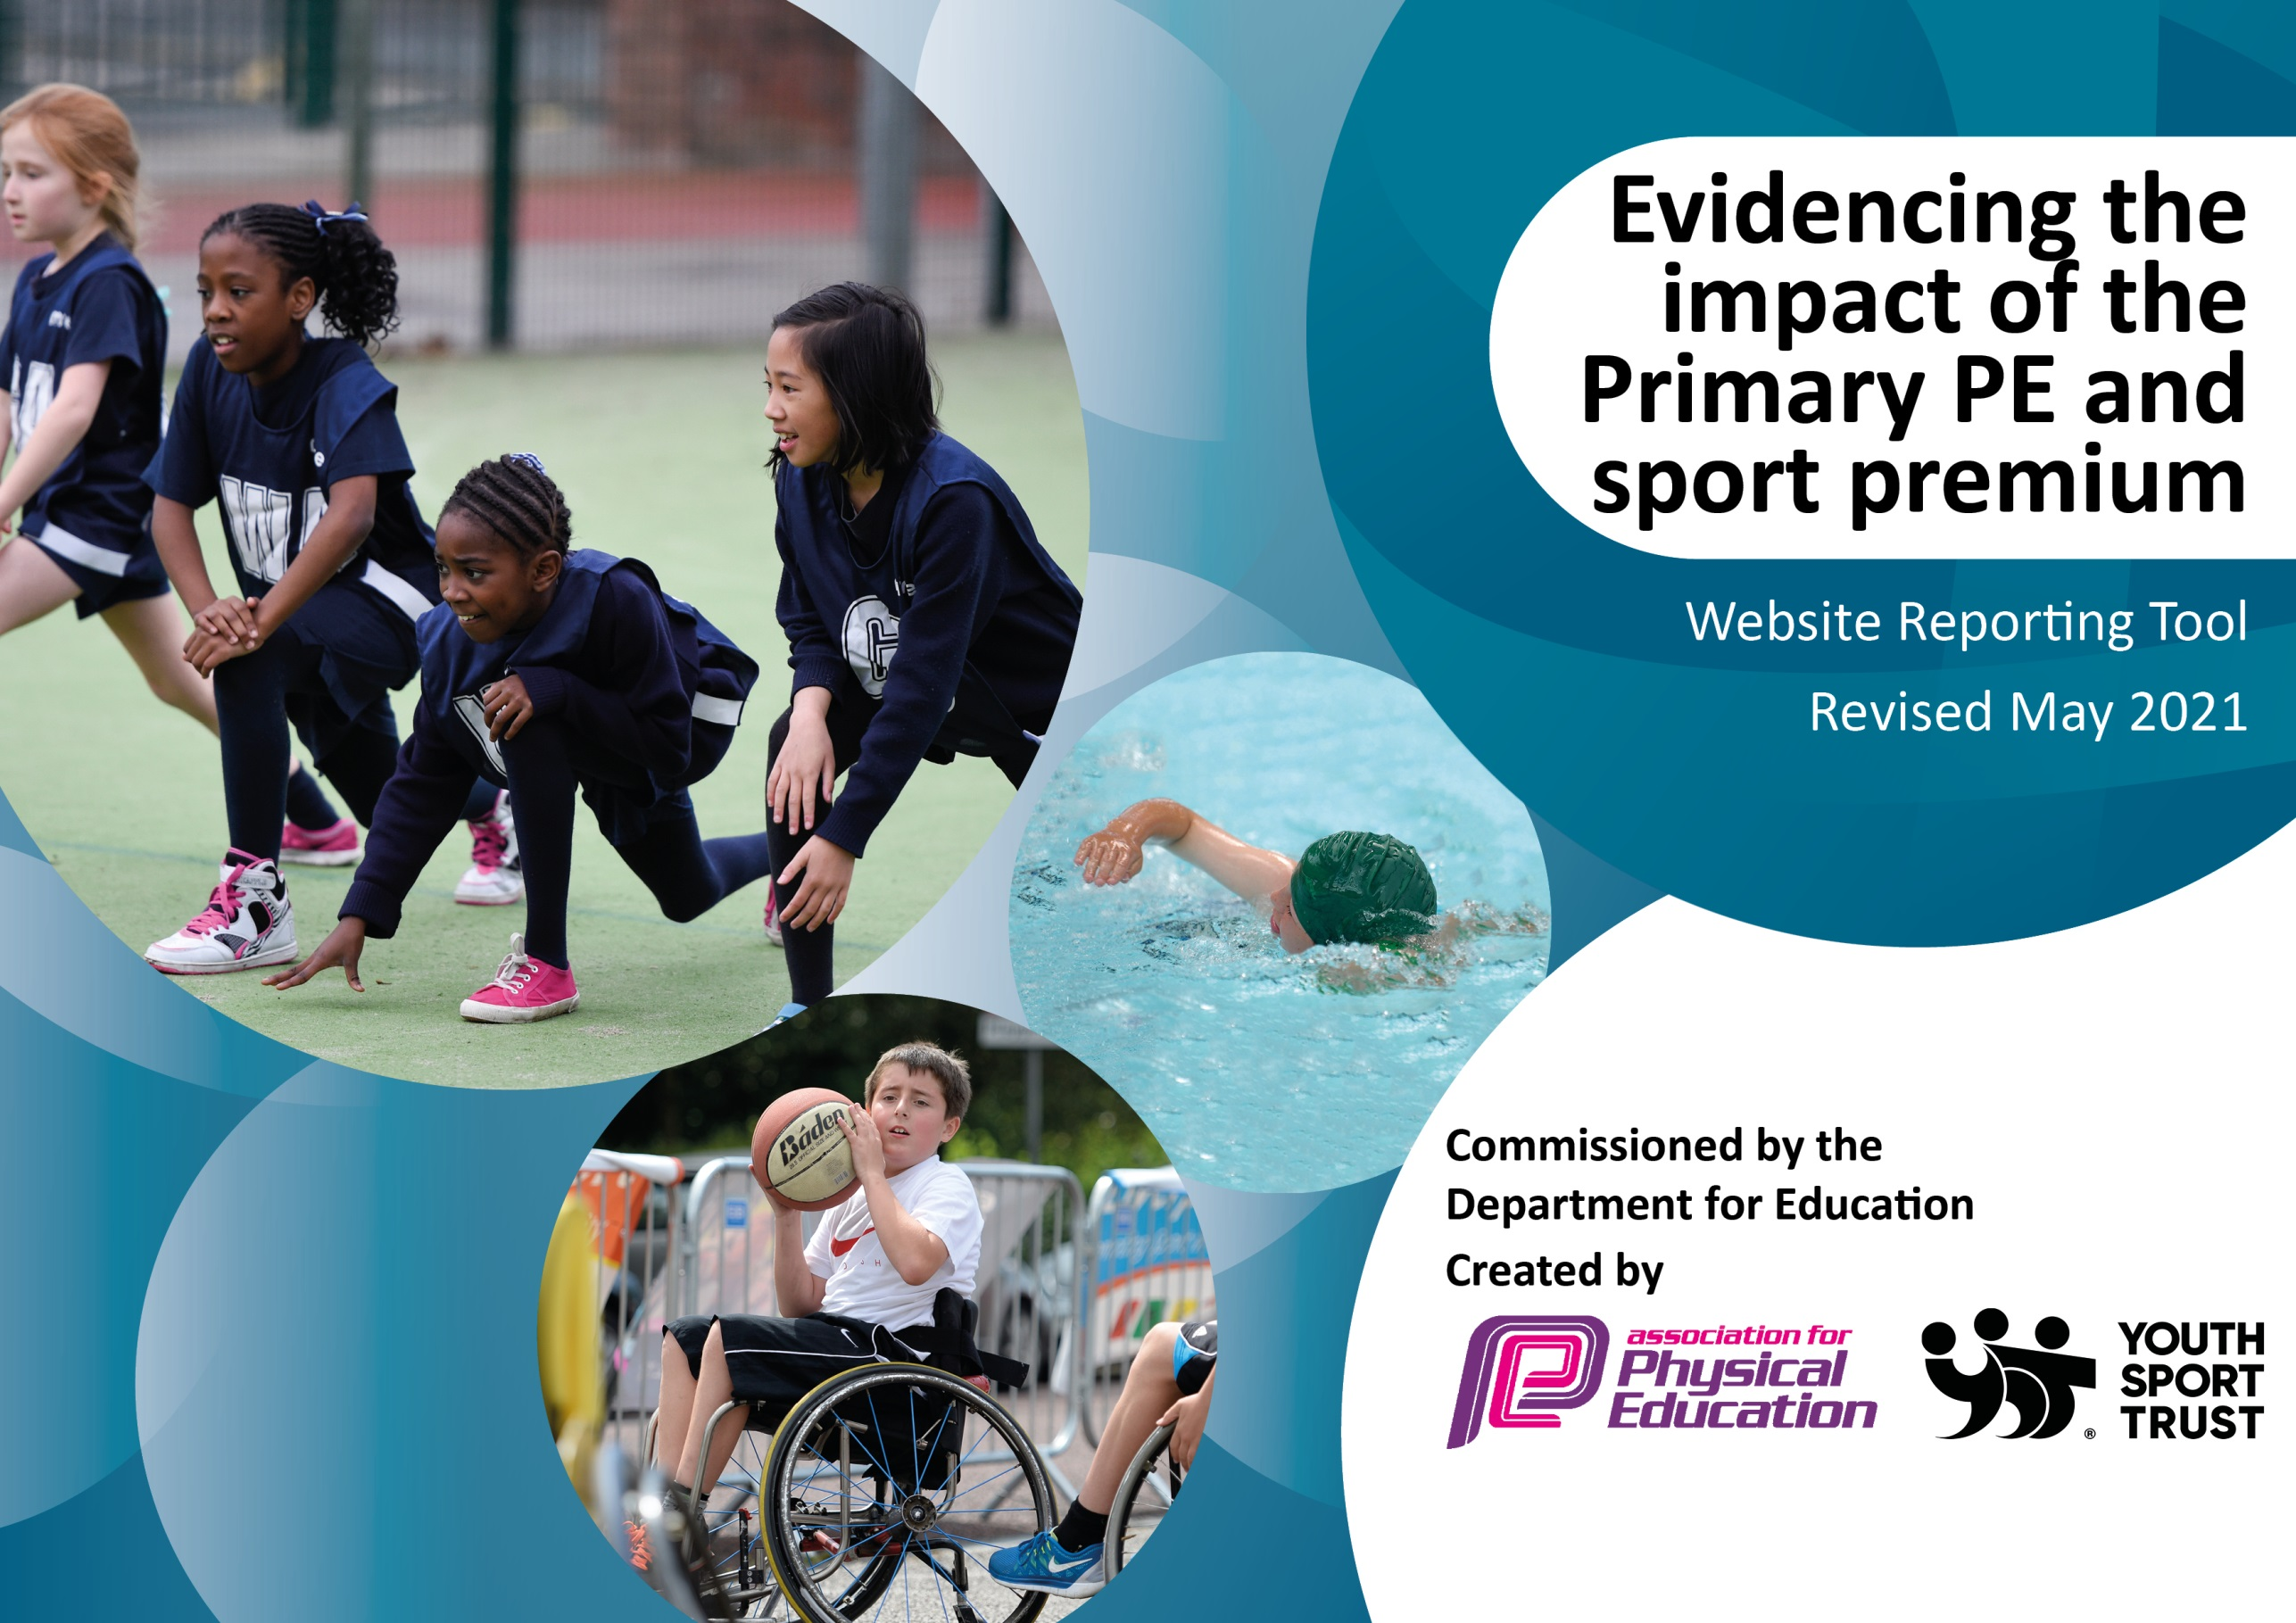

It is important that your grant is used effectively and based on school need. The Education Inspection Framework (Ofsted 2019 p64) makes clear there will be a focus on **‘whether leaders and those responsible for governors all understand their respective roles and perform these in a way that enhances the effectiveness of the school’**.

Under the Quality of Education criteria (p41) inspectors consider the extent to which schools can articulate their curriculum (INTENT), construct their curriculum (IMPLEMENTATION) and demonstrate the outcomes which result (IMPACT).

To assist schools with common transferable language this template has been developed to utilise the same three headings which should make your plans easily transferable between working documents.

Schools must use the funding to make **additional and sustainable** improvements to the quality of Physical Education, School Sport and Physical Activity (PESSPA) they offer. This means that you should use the Primary PE and sport premium to:

* Develop or add to the PESSPA activities that your school already offer
* Build capacity and capability within the school to ensure that improvements made now will benefit pupils joining the school in future years
* The Primary PE and sport premium should not be used to fund capital spend projects; the school’s budget should fund these.

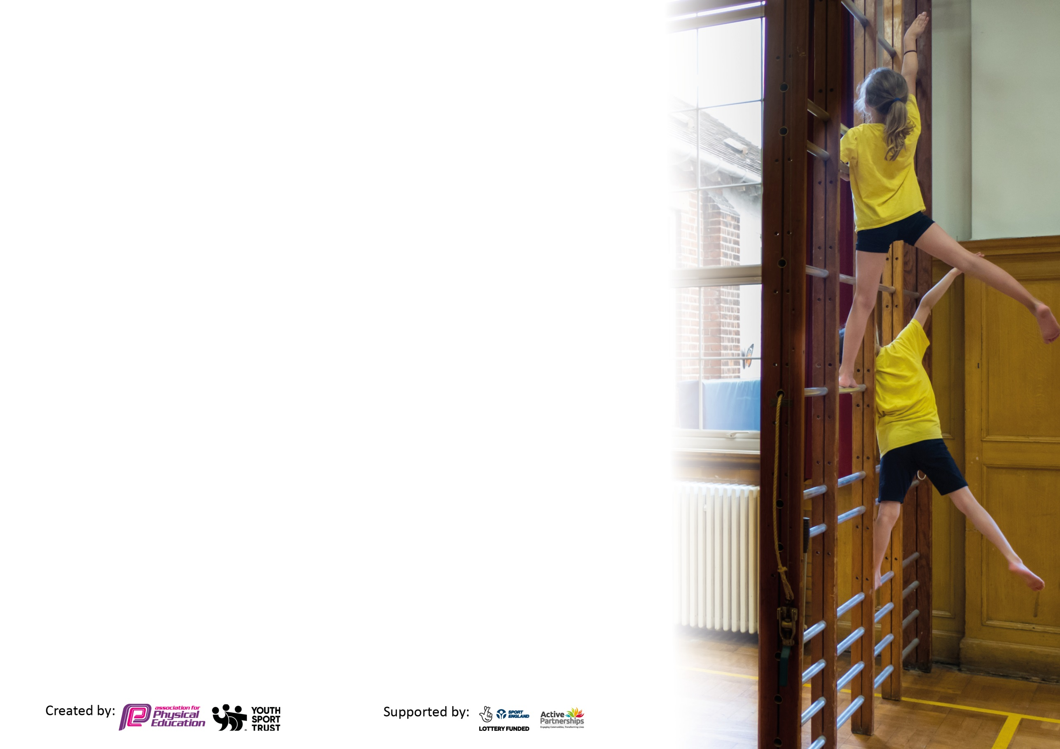

Please visit gov.uk for the revised DfE guidance including the 5 key indicators across which schools should demonstrate an improvement. This document will help you to review your provision and to report your spend. DfE encourages schools to use this template as an effective way of meeting the reporting requirements of the Primary PE and sport premium.

We recommend you start by reflecting on the impact of current provision and reviewing the previous spend.

Schools are required to publish details of how they spend this funding, including any under-spend from 2019/2020, as well as on the impact it has on pupils’ PE and sport participation and attainment by the end of the summer term or by **31st July 2021** at the latest.

We recommend regularly updating the table and publishing it on your website throughout the year. This evidences your ongoing self-evaluation of how you are using the funding to secure maximum, sustainable impact. Final copy must be posted on your website by the end of the academic year and no later than the 31st July 2021. To see an example of how to complete the table please click HERE.



|  |  |
| --- | --- |
| Meeting national curriculum requirements for swimming and water safety.  N.B Complete this section to your best ability. For example you might have practised safe self-rescue techniques on dry land which you can transfer to the pool when school swimming restarts.  **Due to exceptional circumstances priority should be given to ensuring that pupils can perform safe self rescue even**  **if they do not fully meet the first two requirements of the NC programme of study.** |  |
| What percentage of your current Year 6 cohort swim competently, confidently and proficiently over a distance of at least 25 metres?  **N.B.** Even though your pupils may swim in another year please report on their attainment on leaving primary school at the end of the summer term 2022.  Please see note above. | 100% |
| What percentage of your current Year 6 cohort use a range of strokes effectively [for example, front crawl, backstroke and breaststroke]?  Please see note above. | 100% |
| **What percentage of your current Year 6 cohort perform safe self-rescue in different water-based situations?** | 100% |
| Schools can choose to use the Primary PE and sport premium to provide additional provision for swimming but this must be for activity **over and above** the national curriculum requirements. Have you used it in this way? | Yes |

**Action Plan and Budget Tracking**

Capture your intended annual spend against the 5 key indicators. Clarify the success criteria and evidence of impact that you intend to measure to evaluate for pupils today and for the future.

|  |  |  |  |  |
| --- | --- | --- | --- | --- |
| **Academic Year:** 2021/22 | **Total fund allocated:** £17810 | **Date Updated:24/07/2022** | |  |
| **Key indicator 1:** The engagement of all pupils in regular physical activity – Chief Medical Officers guidelines recommend that primary school pupils undertake at least 30 minutes of physical activity a day in school | | | | Percentage of total allocation: |
| 11.8% |
| **Intent** | **Implementation** | | **Impact** |  |
| Your school focus should be clear what you want the pupils to know and be able to do and about  what they need to learn and to  consolidate through practice: | Make sure your actions to achieve are linked to your intentions: | Funding allocated: | Evidence of impact: what do pupils now know and what can they now do? What has changed?: | Sustainability and suggested next steps: |
| Playground Leader roles to be developed (restrictions allowing) to improve the quality of activity at breaktimes and lunch times.  Children to engage in regular physical activity throughout the day – during free time and lessons.  Equipment to be available at breaktimes for children to use and enhance their activity. | Children to apply to become a playground leader so we have children who want to be in this role. Training to be provided by the Newcastle PE and School Sports Service. (NPSSS)  Daily mile to continue in class and staff to be encouraged to allow energy breaks to support wellbeing and concentration – Wake Up Shake Up videos are available to all classes on the school network.  Resources for breaktimes to be audited and resources ordered where necessary.  If online learning is required, PE challenges will be sent home for each school day in conjunction with the NPSSS.  Swimming to be offered to all children in the school as an extra addition to the swimming normally made available to bridge the COVID gap that has emerged. | £0 (part of NPSSS SLA)  £0  £179.97  £0  £1920 | Year 5 children have become more confident with both their leadership skills, but also in different games and activities for younger children. This has allowed children in KS1 to have greater active minutes during the day.  Daily Mile was not engaging children so breaks and lunchtimes have been made more active with adults and playground leaders leading activities and resources available for all outside of structured activity. Wake up shake up has continued in KS1.  Resources ordered for KS1, resources found from original stock for KS2  N/A  Swimming has been offered to Reception and KS1 to give all children the opportunity to have experiences that most have not had due to COVID. This has given the children a good start to reaching 25m by end of Year 6 | This cohort, who will be moving to year 6, will be leaders next year and will be running activities at breaks and lunches. Year 5 children to do Playground leader training to be able to support this year and moving forward to next year. PE lead to continue training from CPD gained.  Resources are available for next year and will be added to with the input of playground leaders to make best use of their knowledge gained in training.  As above.  Online systems are still available in school and will continue to work with NPSSS if online learning is required.  This will give the younger children more opportunity to reach the required expectations of the curriculum quickly and will have the opportunity to work on the quality of their swimming in later years. |
| **Key indicator 2:** The profile of PESSPA being raised across the school as a tool for whole school improvement | | | | Percentage of total allocation: |
| 4.9% |
| **Intent** | **Implementation** | | **Impact** |  |
| Your school focus should be clear what you want the pupils to know and be able to do and about  what they need to learn and to  consolidate through practice: | Make sure your actions to achieve are linked to your intentions: | Funding allocated: | Evidence of impact: what do pupils now know and what can they now do? What has changed?: | Sustainability and suggested next steps: |
| Children’s achievements celebrated with whole school community resulting in a culture of sporting excellence encouraged across the school. PE is seen to be an integral part of their learning – sharing successes from clubs, PE lessons and competitions.  Raised awareness of PE and active lifestyles through use of social media to encourage parents and children to stay active when not at school.  Raise standards, confidence and belief in own ability in all areas of PE to ensure PE is encouraged and supported through whole school means. | Senior leaders and teachers to promote participation of clubs in assembly and in class.  Wider use of the school’s Facebook, Twitter and blogs to celebrate and encourage regular physical activity.  Widen the participation of pupils in competitions by ensuring that different children represent the school at different events.  Whole school PE week to promote the importance and profile of PE across the school and to include Sports Day. | £0  £0  £0  £870 | Parents are regularly sending children’s photos and trophies into school to share in celebration assemblies.  As above. Links have been made with other groups and retweets made where we have been mentioned.  The football clubs have had 29 different children from UKS2 representing school in a variety of tournaments and leagues.  PE week was a success, with children across the school doing many different events including – outdoor adventure, basketball, rugby, dance and sports day at a local professional sports arena where **every** child participated over 6 events. | Continue to build in time each celebration assembly for sporting achievement in and out of school, with a central contact for any photos and information to be sent in.  Social Media links to be strengthened and used more frequently to drive interest in sporting activity.  Football Clubs to be split into 2 – boys and girls so we are following the recommendations agreed with girlsfootballinschools.org that we would have equal offerings for both sexes.  PE week to be planned in a similar way with a variety of activities, but will focus on new sports not offered and also build on CPD as part of the week. |

|  |  |  |  |  |
| --- | --- | --- | --- | --- |
| **Key indicator 3:** Increased confidence, knowledge and skills of all staff in teaching PE and sport | | | | Percentage of total allocation: |
| 26.1% |
| **Intent** | **Implementation** | | **Impact** |  |
| Your school focus should be clear | Make sure your actions to | Funding | Evidence of impact: what do | Sustainability and suggested |
| what you want the pupils to know | achieve are linked to your | allocated: | pupils now know and what | next steps: |
| and be able to do and about | intentions: |  | can they now do? What has |  |
| what they need to learn and to |  |  | changed? |  |
| consolidate through practice: |  |  |  |  |
| Development of leaders skills and knowledge to further enhance provision for the whole school through planning meetings with SLA and school staff  Attend PE meetings and networks to stay up to date with latest developments and recommendations for high quality PE teaching  To improve knowledge of all staff in delivering and supporting PE.  Encourage school staff to attend CPD led by NPSSS SLA to upskill and help increase confidence and knowledge of delivering PE especially in areas of need. | Buy in to Gold level SLA with NPSSS to support lead and school to develop curriculum, training and improvements in teaching.  Cover for subject leader to attend PE network meetings and planning meetings throughout the year.  Audit of staff knowledge to be made early in the school year to match needs with available training through SLA  Training to be organised to match needs of teachers across the school.  External provider to lead Dance for dance festival to support teacher to upskill, along with kit for Dance Festival.  Cover for teachers and support staff to engage with CPD.  Football Coaching course for subject leader to be organised | £3000 (NPSSS SLA)  £280  £0  £0  £359.70  £1000  £0 | PE Lead has more confidence in delivering a balanced curriculum and this has been delivered by staff throughout the year. Focus has been made on covering the requirements of the curriculum but giving a wide variety of sports and activity to accomplish this.  Staff knowledge is good and this has been shown in excellent PE lessons.  Training in Dance was completed later in the year and so impact will be felt in the next academic year when teaching of dance will be undertaken. Year 2 have had a very positive experience of Dance from a professional dance teacher and has proved valuable CPD for teacher and assistant in that class.  Football coaching was carried out at the beginning of the year and this had impact in out of school clubs with 30 out of a possible 60 children attending from UKS2. | PE Lead to continue to build on staff knowledge through new SLA partnership with Newcastle United where all staff will be having in lesson CPD with professional coaches.  Gymnastics to be a focus for whole staff CPD as this was another area of concern for many staff.  Dance will be monitored and further training from coaches will be booked if needed to build on last years CPD.  Football coaching to be organised and attended by PE lead and Football club staff to enhance quality of coaching through gaining qualifications. |
| **Key indicator 4:** Broader experience of a range of sports and activities offered to all pupils | | | | Percentage of total allocation: |
| 28.7% |
| **Intent** | **Implementation** | | **Impact** |  |
| Your school focus should be clear | Make sure your actions to | Funding | Evidence of impact: what do | Sustainability and suggested |
| what you want the pupils to know | achieve are linked to your | allocated: | pupils now know and what | next steps: |
| and be able to do and about | intentions: |  | can they now do? What has |  |
| what they need to learn and to |  |  | changed?: |  |
| consolidate through practice: |  |  |  |  |
| Build greater links with local sporting teams to broaden children’s awareness and participation in sports.  Develop use of after school and during school sporting opportunities through use of clubs – including staff led and coach led clubs.  All children given access to swimming lessons from Reception to Year 6.  Attend a wide variety of sporting events (festivals, tournaments) to give children the broadest experience of competition and build aspirations.  Develop the outdoor area so that we can deliver more OAA lessons across the year in both school time and after school clubs.  Outdoor residential event to be organised for Year 6 to engage in OAA which cannot be done on site. | Year 5 and 6 to work with Newcastle Eagles to deliver curriculum sessions at the Eagles arena / School with an aim to upskill staff and educate pupils in basketball by specialists.  Equipment to be bought to enhance both the basketball with Newcastle Eagles, but will also allow all PE sessions to have the resources needed.  To use Magic Weekend in Newcastle and the impending Rugby League World Cup in late 2022, to support rugby teaching in school  Clubs to be run by school staff based around sports across the whole year.  Swimming has been booked for full mornings to allow as many children to go swimming. EYFS / KS1 to begin in the first term and then move to KS2, focusing on children that need safety and basic swimming skills.  When available, children will be entered into festivals and tournaments. Sports day to be organised at the end of the summer term to allow all children to participate in events.  Work with expert to deliver a number of afternoon sessions with KS2 classes for Outdoor learning, Teacher and PE lead to use as CPD session for next year.  Payment towards Year 6 Outdoor Residential to support children who may not be able to afford the cost of the event, as well as paying for extra activities on site. | £2290  £800  £300  £0  £0  £0  £1050  £676 | Basketball has become a key driver of activity both at breaks/lunchtimes and after school where many children attend the Newcastle Eagles sessions themselves. We have had 1 child who has been asked by 2 professional players to join the Eagles youth team.  In the final half term, Newcastle Thunder were booked to come into school and give children the experience of rugby which we had previously not done in school, and 5 children were able to experience the Magic Weekend in Newcastle and the whole of KS2 were able to see the actual Super League trophy. Children are now more interested in a new sport and will continue as the World Cup approaches.  Clubs have run across the year, with football, basketball and running being the key sessions. Football had 30 out of 60 children attend from UKS2.  Swimming has been a massive success and the extra sessions we organise for EYFS/KS1 across the years have shown dividends with the Year 6 cohort now leaving with every child able to swim 25m and perform safe rescues in the pool. (Last year 33% left able to swim 25m)  Children have been entered into many sporting events where we have been able to attend such as many boys and girls football competitions, along with basketball and athletics. Sports Day at Newcastle Eagles Arena allowed all children to participate in 75 minutes of activity along with everyone in their key stage.  Outdoor learning sessions have given all children in KS2 experience of outdoor adventurous activity and children have shown greater interest in being outside doing many different activities, not just ones done on the day.  Year 6 were able to participate in more adventurous activity at a residential site with activities such as Kayaking, Canoeing, Climbing and Hiking, which they would not have been able to do in school or over the previous years due to COVID. | Basketball equipment will be available for children but will continue as after school clubs. Hoops for Health will continue to allow children to have access to high quality competitive events with our local professional club.  Rugby League World Cup begins in Newcastle in October so this will be a focus for the school in the first half term, through either events in school / after school or through the Newcastle Rugby Foundation.  After school clubs to be a focus this year and children have been surveyed and the results will be used to build an after school offering for ages across the school.  Swimming to continue as previously, but KS2 will begin the year and then focus will turn to KS1 as we move through the academic year. This is so we continue our COVID catch up and ensure that all at Y6 will achieve the expected level.  Tournaments and festivals to be continued throughout the year. Where possible, a variety of classes and staff to access these activities as this year it has been UKS2 who have had the bulk of the activities and we may need to look further to find more activity for KS1/LKS2.  Outdoor equipment to be purchased so that we can carry out our own outdoor sessions in school and so give us more control over the content of our sessions but also to allow staff to use the training they have been given this year.  Knowledge gained from Outdoor days in school will be used to develop our own curriculum for outdoor learning. Availability of more adventurous activity not available on school site to be researched |

|  |  |  |  |  |
| --- | --- | --- | --- | --- |
| **Key indicator 5:** Increased participation in competitive sport | | | | Percentage of total allocation: |
| 28.5% |
| **Intent** | **Implementation** | | **Impact** |  |
| Your school focus should be clear | Make sure your actions to | Funding | Evidence of impact: what do | Sustainability and suggested |
| what you want the pupils to know | achieve are linked to your | allocated: | pupils now know and what | next steps: |
| and be able to do and about | intentions: |  | can they now do? What has |  |
| what they need to learn and to |  |  | changed?: |  |
| consolidate through practice: |  |  |  |  |
| Increase in attendance in city-wide competitions and events for children of all ages and abilities and across disciplines to consolidate skills.  Develop Sports Leaders to organise competition.  Continued promotion of local sports clubs.  Whole school PE week planned with Sports Day the culmination of a variety of different sports and games with inter-house and inter-key stage competition. | Use NPSSS to know of all events available through SLA and other partners.  Transport via minibuses available for all sporting events, both festivals and L1 and L2 competition.  Payments for local FA affiliation for competitive events.  New sports team clothing to be purchased with new school logo, and will also be made available to staff so that we can attend events professionally and build self esteem and worth representing the school and themselves.  Cover available for staff to support Sports Leaders to plan and organise competitive events.  Promote local sports clubs and celebrate the successes of children who attend clubs to encourage other children to get involved.  Celebrate successes both inside and outside of school in assemblies and through blogs / social media / Headteachers Weekly message. These are shared with the whole school community on the school website.  PE week planned to encourage children to partake in competitive sport (inter house and across year groups) All children to be involved in Sports Day. | £0  £2000  £250  £2644.25  £190  £0  £0  £0 | Children have been able to attend many events across the city, mainly in UKS2. Other children have had healthy active lifestyles workshops and have built skills to enjoy physical activity rather than in competitive events.  We have been able to compete in a variety of football competitions across the region  New Sports clothing has had an impact on staff and children as we now have the correct kit for the sports we take part in and this has built the confidence of the teams using them as well as a sense of belonging.  Sports leaders have been trained and have been leading games and activities in EYFS and KS1  Promotion of sports has been a big success and both children and parents have sent in pictures and awards to celebrate in assembly. There are now more children in outside clubs and events than at the beginning of the year, with many playing on new football teams, gymnastics, dance and cheer dance.  Sports Week highlighted the importance of physical activity and the children all had at least 2/3 different sessions across the week. Children have used these sessions and have used them in their play at breaks and lunch times, as well as making links with different clubs. | Continue to use local clubs / SLA’s to build events throughout the year, making a particular focus on KS1/LKS2.  FA affiliation will continue next year and give us access to competitions across Newcastle and Northumberland.  Sports clothing to continue to be built, with new kit to arrive in the new academic year for the sports teams. Lead to consider the need to fund PE kit for children so that everyone has a PE kit in school and no child is left out.  New Y6 to continue their activities, New Y5 cohort to undertake training to support and lead in 23/24.  Promotion of sports in assembly to continue each week and parents to be asked to send as many pictures/awards into school so we can celebrate with the children their sporting achievements.  Sports Week to become a regular event in the years calendar and will be organised based on the events happening next summer and to try and build links with local clubs to build pathways |

|  |  |
| --- | --- |
| Signed off by | |
| Head Teacher: | S Henzell |
| Date: | 27/07/22 |
| Subject Leader: | C Wallace |
| Date: | 27/07/22 |
| Governor: | C Baker |
| Date: | 28/07/22 |