Our Lady & St Anne’s Catholic Primary School
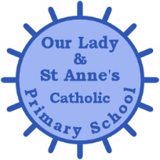

Mini-Bus Driver
Salary Grade BB02 £20,812 per annum pro rata - actual salary £1,651 per annum
Term time only
3.5 hrs per week (9.30am – 1pm Tues)
(Additional hours may be required to cover any out of school activities on an adhoc basis)
Permanent Contract
*This post attracts a Living Wage supplement. In addition to the hourly rate, this post will receive the Living Wage supplement to bring the hourly rate up to a minimum of £10.90 an hour.*

Required for Immediate Appointment

The Governors are seeking to appoint a suitably qualified enthusiastic and well-motivated bus driver to join our team.

We are looking for someone who:

- Supports the Catholic ethos of our school
- Is extremely organised
- Has high expectations
- Works as part of a team to achieve very high standards
- Has a good sense of humour!

The Governing Body is strongly committed to safeguarding and promoting the welfare of children and young people. The post is subject to an Enhanced Certificate of Disclosure from the Disclosure and Barring Service and a range of other recruitment checks.

Application forms and further details are available on the school website only. www.olsa.org.uk.

Completed applications are to be returned by email to the School Business
Manager to recruitment@olsa.org.uk

Closing Date: Friday 1st December 2023
Shortlisting: TBC
Interview TBC

