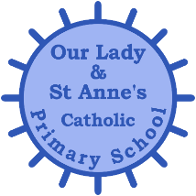
Reception - Communication and Language Objectives
Autumn Term  Understand how to listen carefully and why listening is important.  Develop social phrases.  Learn new vocabulary.  Listen carefully to rhymes and songs, paying attention to how they sound.  Engage in story times. Learn rhymes, poems and songs.  Hold conversation when engaged in back-and-forth exchanges with their teacher and peers.  Connect one idea or action to another using a range of connectives.  Use talk to help work out problems and organise thinking and activities, and explain how things work and why they might happen. | Spring Term  Use new vocabulary throughout the day.  Ask questions to find out more and to check they understand what has been said to them.  Make comments about what they have heard and ask questions to clarify their understanding.  Participate in small group, class and one-to-one discussions, offering their own ideas, using recently introduced vocabulary.  Listen to and talk about stories to build familiarity and understanding.  Retell the story, once they have developed a deep familiarity with the text, some as exact repetition and some in their own words.  Engage in non-fiction books. Listen to and talk about selected non-fiction to develop a deep familiarity with new knowledge and vocabulary. | Summer Term  Listen attentively and respond to what they hear with relevant questions, comments and actions when being read to and during whole class discussions and small group interactions.  Use new vocabulary in different contexts.  Articulate their ideas and thoughts in well-formed sentences. Describe events in some detail.  Offer explanations for why things might happen, making use of recently introduced vocabulary from stories, non-fiction, rhymes and poems when appropriate.  Express their ideas and feelings about their experiences using full sentences, including the use of past, present and future tenses and making use of conjunctions, with modelling and support from their teacher

Reception - Personal, Social and Emotional Development Objectives
Autumn Term  See themselves as a valuable individual.  Form positive attachments to adults and friendships with peers.  Express their feelings and consider the feelings of others.  Be increasingly independent in meeting their own care needs, e.g brushing teeth, using the toilet, washing and drying their hands thoroughly.  Make healthy choices about food, drink, activity and toothbrushing. | Spring Term  Build constructive and respectful relationships.  Identify and moderate their own feelings socially and emotionally.  Work and play cooperatively and take turns with others.  Think about the perspectives of others.  Show resilience and perseverance in the face of challenge.  Set and work towards simple goals, being able to wait for what they want and control their immediate impulses when appropriate.  Manage their own basic hygiene and personal needs, including dressing, going to the toilet and understanding the importance of healthy food choices. | Summer Term  Show an understanding of their own feelings and those of others, and begin to regulate their behaviour accordingly.  Show sensitivity to their own and to others’ needs.  Give focused attention to what the teacher says, responding appropriately even when engaged in activity, and show an ability to follow instructions involving several ideas or actions.  Be confident to try new activities and show independence, resilience and perseverance in the face of challenge.  Explain the reasons for rules, know right from wrong and try to behave accordingly.  Know and talk about the different factors that support their overall health and wellbeing: - regular physical activity - healthy eating - toothbrushing - sensible amounts of ‘screen time’ - having a good sleep routine - being a safe pedestrian

Reception - Physical Development Objectives
Autumn Term  Revise and refine the fundamental movement skills they have already acquired: - rolling - walking - running - skipping - crawling - jumping - hopping - climbing  Use their core muscle strength to achieve a good posture when sitting at a table or sitting on the floor.  Confidently and safely use a range of large and small apparatus indoors and outside, alone and in a group.  Develop and refine a range of ball skills including: throwing, catching, kicking, passing, batting, and aiming.  Develop confidence, competence, precision and accuracy when engaging in activities that involve a ball.  Further develop the skills they need to manage the school day successfully: - lining up and queuing – mealtimes.  Use a range of small tools, including tweezers, paintbrushes and cutlery. | Spring Term  Progress towards a more fluent style of moving, with developing control and grace. Combine different movements with ease and fluency.  Begin to develop the overall body strength, co-ordination, balance and agility needed to engage successfully with physical education sessions and other physical disciplines including dance, gymnastics, sport.  Develop their small motor skills so that they can use a range of tools competently, safely and confidently e.g. pencils, scissors, knives, forks and spoons.  Hold a pencil effectively in preparation for fluent writing – using the tripod grip in almost all cases.  To begin to show accuracy and care when drawing. | Summer Term  Negotiate space and obstacles safely, with consideration for themselves and others.  Move energetically, such as running, jumping, dancing, hopping, skipping and climbing.  Demonstrate strength, balance and coordination when playing.  Begin to develop the confidence and skills needed in order to swim.  Develop the foundations of a handwriting style which is fast, accurate and efficient.

Reception - Literacy Objectives
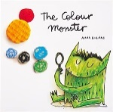  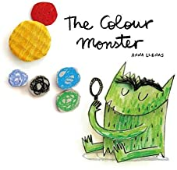  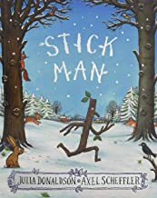  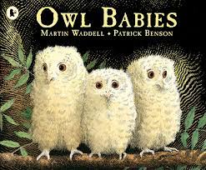  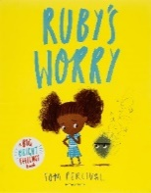  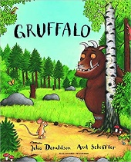  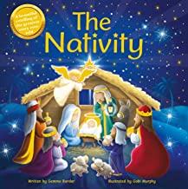 | 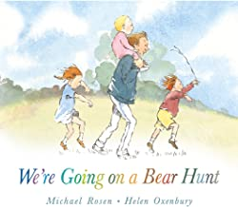  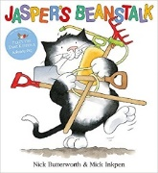  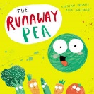  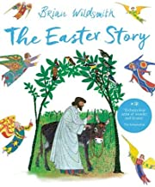 | 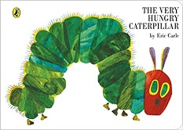  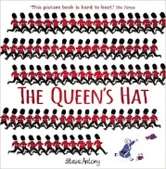  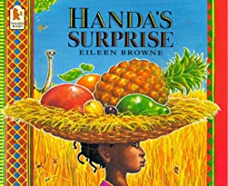  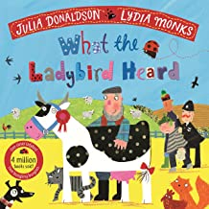
Autumn Term  Engage in extended conversations about stories, learning new vocabulary.  Develop their phonological awareness, so that they can:  -spot and suggest rhymes  - count or clap syllables in a word  -recognise words with the same initial sound, such as money and mother  Read individual letters by saying the sounds for them  Blend sounds into words, so that they can read short words made up of known letter– sound correspondences.  Use some of their print and letter knowledge in their early writing. For example, writing ‘m’ for mummy.  Write some letters accurately.  Write own name. | Spring Term  Use and understand recently introduced vocabulary during discussions about stories, non-fiction, rhymes and poems and during role-play.  Re-read stories to build up their confidence in word reading, their fluency and their understanding and enjoyment.  Read some letter groups that each represent one sound and say sounds for them.  Read words consistent with their phonic knowledge by sound-blending.  Read and spell a few common exception words matched to the school’s phonic programme.  Spell words by identifying the sounds and then writing the sound with letter/s.  Write simple sentences, using known sound-letter correspondences. | Summer Term  Demonstrate understanding of what they have read by retelling stories and narratives using their own words and recently introduced vocabulary.  Anticipate – where appropriate – key events in stories.  Say a sound for each letter in the alphabet and at least 10 digraphs.  Read aloud simple sentences and books that are consistent with their phonic knowledge, including some common exception words.  Spell words by identifying sounds in them and representing the sounds with a letter or letters.  Write short sentences with words with known sound-letter correspondences using a capital letter and full stop.  Begin to extended sentences using ‘and’.  Write phrases and sentences that can be read by others. Re-read own writing to check it makes sense
-Story Maps -Lists -Descriptions -Recounts  Captions | -Story Maps -Narratives -Recounts -Letters  Instructions | -Information Texts - Narratives - Descriptions -Recounts - Instructions
Reception - Maths Objectives

Autumn Term  Count objects, actions and sounds up to 10 confidently.  Know that the last number reached when counting a small set of objects tells you how many there are in total (‘cardinal principle’).  Link numerals and amounts: for example, showing the right number of objects to match the numeral, up to 5  Explore the composition of numbers to 5.  Develop fast recognition of up to 5 objects, without having to count them individually (‘subitising’)  Talk about and explore 2D and 3D shapes using informal and mathematical language: ‘sides’, ‘corners’; ‘straight’, ‘flat’, ‘round’.  Make comparisons between objects relating to size, length, weight and capacity.  Copy and create repeating patterns.  Justify their answers using knowledge of numerical concepts or simple mathematical vocabulary. | Spring Term  Link the number symbol (numeral) with its cardinal number value up to 10.  Count beyond ten.  Understand the ‘one more than/one less than’ relationship between consecutive numbers.  Explore the composition of numbers to 10.  Automatically recall number bonds for numbers 0–5 and some to 10.  Select, rotate and manipulate shapes in order to develop spatial reasoning skills.  Compose and decompose shapes so that children recognise a shape can have other shapes within it, just as numbers can.  Continue and create repeating patterns. Discuss the type of pattern they have used using the mathematical vocabulary of AB.  Compare the length, weight and capacity of numerous objects.  Begin to develop reasoning skills during mathematical discussion, using prior knowledge and mathematical vocabulary. | Summer Term  Have a deep understanding of number to 10, including the composition of each number.  Automatically recall (without reference to rhymes, counting or other aids) number bonds up to 5 (including subtraction facts) and some number bonds to 10, including double fact.  Verbally count beyond 20, recognising the pattern of the counting system.  Compare quantities up to 10 in different contexts, recognising when one quantity is greater than, less than or the same as the other quantity.  Explore and represent patterns within numbers up to 10, including evens and odds and doubling.  Explore how quantities can be distributed equally.  Develop reasoning skills during discussion, using prior knowledge and mathematical vocabulary.
Reception - Understanding the World Objectives
Autumn Term  Talk about members of their immediate family and community.  Name and describe people who are familiar to them.  Comment on images of familiar situations in the past.  Explore the natural world around them.  Describe what they see, hear and feel whilst outside.  Recognise some environments that are different to the one in which they live.  Continue developing positive attitudes about the differences between people.  Know that there are different countries in the world and talk about the differences they have experienced or seen in photos.  Recognise that people have different beliefs and celebrate special times in different ways. (Judaism Focus)  Understand the effect of changing seasons on the natural world around them (Autumn to Winter). | Spring Term  Compare and contrast characters from stories, including figures from the past.  Draw information from a simple map.  Recognise some similarities and differences between life in this country and life in other countries.  Know some similarities and differences between different religious and cultural communities in this country, drawing on their experiences and what has been read in class. (Chinese New Year Focus)  Understand that some places are special to members of their community.  Understand some important processes and changes in the natural world around them, including the seasons and changing states of matter. (Spring to Summer)  Explore the natural world around them, making observations and drawing pictures of plants.  Understand the key features of the life cycle of a plant. Begin to understand the need to respect and care for the natural environment and all living things. To learn what a plant needs in order to grow. | Summer Term  Talk about the lives of the people around them and their roles in society.  Know some similarities and differences between things in the past and now, drawing on their experiences and what has been read in class.  Understand the past through settings, characters and events encountered in books read in class and storytelling.  Describe their immediate environment using knowledge from observation, discussion, stories, non-fiction texts and maps.  Understand that people have different beliefs and celebrate special times in different ways. (Islam Focus)  Explain some similarities and differences between life in this country and life in other countries, drawing on knowledge from stories, non-fiction texts and (when appropriate) maps. (Africa Focus)  Know some similarities and differences between the natural world around them and contrasting environments, drawing on their experiences and what has been read in class.  Understand the key features of the life cycle of a Butterfly/ Frog. Understand the need to respect and care for the natural environment and all living things.

Reception - Expressive Arts and Design Objectives
Autumn Term  Explore, use and refine a variety of artistic effects to express their ideas and feelings.  Return to and build on their previous learning, refining ideas and developing their ability to represent them.  Create collaboratively, sharing ideas, resources and skills.  Sing in a group or on their own, increasingly matching the pitch and following the melody.  Develop storylines in their pretend play. | Spring Term  Listen attentively, move to and talk about music, expressing their feelings and responses.  Watch and talk about dance and performance art, expressing their feelings and responses.  Explore and engage in music-making and dance, performing solo or in groups.  Make use of props and materials when role-playing characters in narratives and stories.  Sing a range of well-known nursery rhymes and songs. | Summer Term  Safely use and explore a variety of materials, tools and techniques, experimenting with colour, design, texture, form and function.  Share their creations, explaining the process they  have used.  Invent, adapt and recount narratives and stories with peers and their teacher.  Perform songs, rhymes, poems and stories with others, and try to move in time with music.

